Data Profiling & Analysis
Anushka Sawant

Step 1: Loading the Dataset
Dataset: tableau_prep_cleaning_exercise.csv | 100 rows × 18 columns

Step 2: Profile the Dataset (Before Cleaning)

2a. Missing Values
Column | Null Count
Satisfaction_Score | 15
Payment_Method | 14
Customer_Segment | 12
Email | 10
Notes | 10
Age | 7
Order_Date | 5
City | 3

2b. Data Type Issues
Column | Tableau Prep Infers | Correct Type
Order_Date | String | Date
Ship_Date | String | Date
All others | Correct | Correct

2c. Value Distributions
Column | Issue
Country | Language variants (Deutschland/Germany, España/Spain) + case
Product_Category | Case noise: 'electronics', 'ELECTRONICS', 'Electronics'
Customer_Segment | Case noise: 'CORPORATE', 'corporate', 'Corporate'
Payment_Method | Case noise: 'bank transfer', 'Bank Transfer'
Customer_Name | Same person in different cases/spacing
Unit_Price | Sentinel value 9999.99 in 5 rows
Age | 2 rows with Age = 130 (impossible)
Quantity | 4 rows with Quantity = 0

2d. Duplicates
- 5 exact duplicate rows found (rows 96–100 are copies of rows 5, 18, 29, 49, 65)
- All 5 share the same Order_ID as their originals — confirmed duplicates, not re-orders

2e. Cardinality of Key Columns
Column | Unique Count
Order_ID | 95 of 100
Customer_ID | 46
Customer_Name | 39
Email | 15
Country | 15
Product_Category | 10
Unit_Price | 93

Step 3: Column Analysis

3a. Which columns have many unique values?
Column | Unique
Sales | 92
Unit_Price | 93
Order_Date | 82
Ship_Date | 87
Customer_ID | 46
Age | 43

3b. Which columns may be used as identifiers?
Column | Row Identifier?
Order_ID | YES (after dedup)
Customer_ID | No
Email | YES
Customer_Name | No

3c. Validity of Dates, Emails, Categories, and Numerics
Field | Issue
Order_Date | 5 date formats; 5 null rows
Ship_Date | 'not available' string
Email | 10 nulls, 0 invalid patterns
Country | Language + case variants
Product_Category | Case variants only
Customer_Segment | Case variants + nulls
Quantity = 0 | Zero-quantity orders
Age = 130 | Impossible age value
Unit_Price = 9999.99 | Sentinel/placeholder

Step 4: Structure Analysis

4a. Can Order_ID identify records?
- These 5 duplicates are exact full-row copies, same Order_ID, same values, same everything
- After deduplication: 95 rows, 95 unique Order_IDs to Order_ID is a valid primary key

4b. Can Customer_ID identify records?
- 46 unique Customer_IDs across 100 rows , customers appear multiple times
- Customer_ID is a foreign key (many-to-one), not a row identifier

4c. Does the Sales formula hold?
Formula to verify: Sales = Quantity × Unit_Price × (1 − Discount)
- For rows with real Unit_Price values: the formula is consistent. So, Sales is correctly derived
- For 5 rows where Unit_Price = 9999.99 (sentinel): Sales is inflated (up to €56,999.94)

4d. Is Customer_Name consistent per Email?
- 13 emails map to more than one Customer_Name variant
- Example: mehdi.karimi@example.com is 'MEHDI KARIMI', 'Mehdi Karimi', 'mehdi karimi', 'Mehdi Karimi ' (trailing space)

Step 5: Cleaning Rules
# | Issue | Column(s) | Action | Logic
1 | Duplicates | All | Remove | Exact matches (Order ID) are redundant.
2 | Missing Dates | Order_Date | Drop Row | Can't analyze a sale without a date.
3 | Mixed Formats | Dates | DATEPARSE | Standardize weird strings into Date types.
4 | "Not Available" | Ship_Date | Set to Null | It's an optional field; better empty than text.
5 | Country Typos | Country | Group/Map | Merged "Deutschland" and "Germany" into one.
6 | Case/Spaces | Various | Trim & Proper | Fixed "city ", "CITY", and "City" into one format.
7 | Null Segment | Cust_Segment | Mode (Corp) | Assigned the most common value (Corporate).
8 | Null Payment | Payment | Mode (Bank) | Assigned "Bank Transfer" to fill gaps.
9 | Age = 130 | Age | Median (45) | Overwrote impossible ages with the middle.
10 | Null Age | Age | Median (45) | Standard fill for missing demographics.
11 | Price = 9999 | Price | Cat. Median | Replaced "sentinel" values with category average.
12 | Null Price | Price | Cat. Median | Grouped by category to get a realistic price.
13 | Sales Errors | Sales | Recalculate | Redid math: Qty * Price * (1-Disc).
14 | Qty = 0 | Quantity | Drop Row | A zero-item order is an error.
15 | Null Notes | Notes | "Unknown" | Categorical fill so it shows up in filters.
16 | Null Score | Sat_Score | Leave Null | Don't fake customer feedback.
17 | Null City/Email | City, Email | Leave Null | Not essential for the dashboard.

Step 6: Tableau Transformations

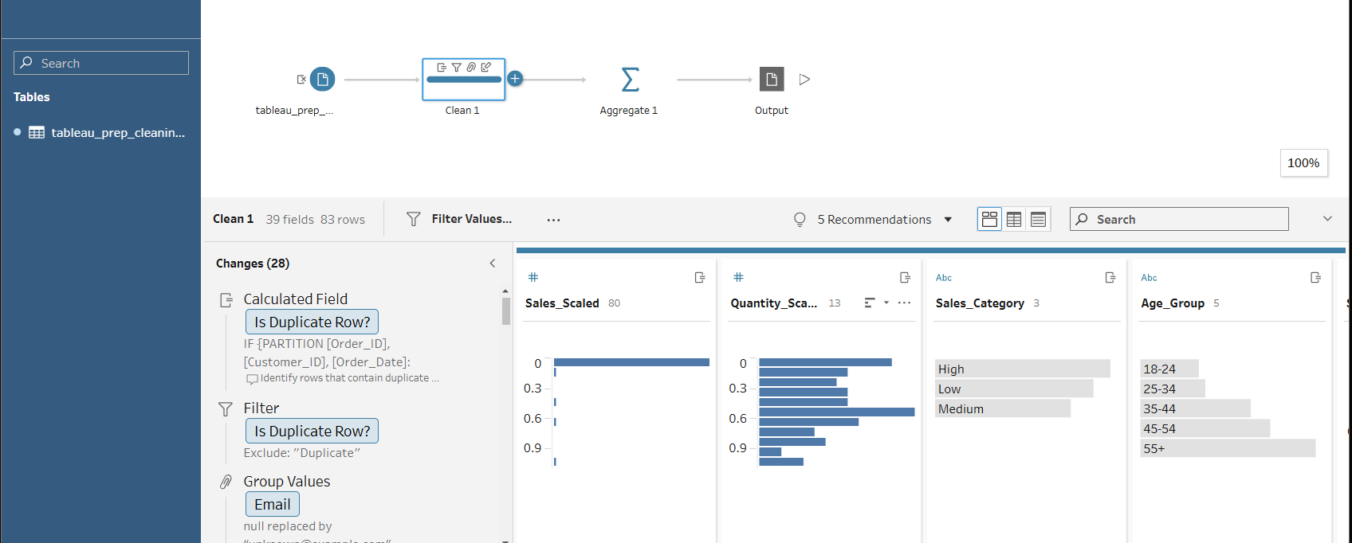

Step 7 & 8: Validation and Export

Row Check: Confirmed row count dropped (due to duplicates/null dates) and matches our expected "clean" count.

Data Types: Verified in Prep that Dates are Calendar icons and Numbers are Hash icons.

Final Output: Exported as a .hyper file for Tableau Desktop to keep the dashboard fast.

Step 9 : Pipeline Context: ETL vs. ELT

Which approach is better for this dataset?

ETL (Tableau Prep approach) is better if:

The dataset is moderately sized (millions of rows, not billions).

Data privacy is a concern (you want to mask or remove PII before it lands in storage).

The users are business analysts who prefer a visual interface over writing complex SQL inside a data warehouse.

